New Requirements
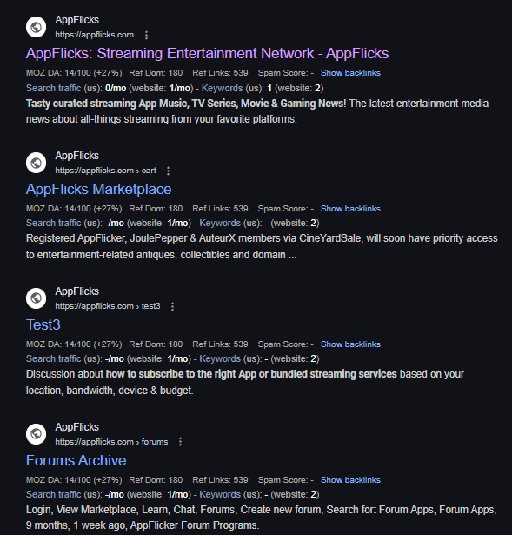
- Logo for the whole website.
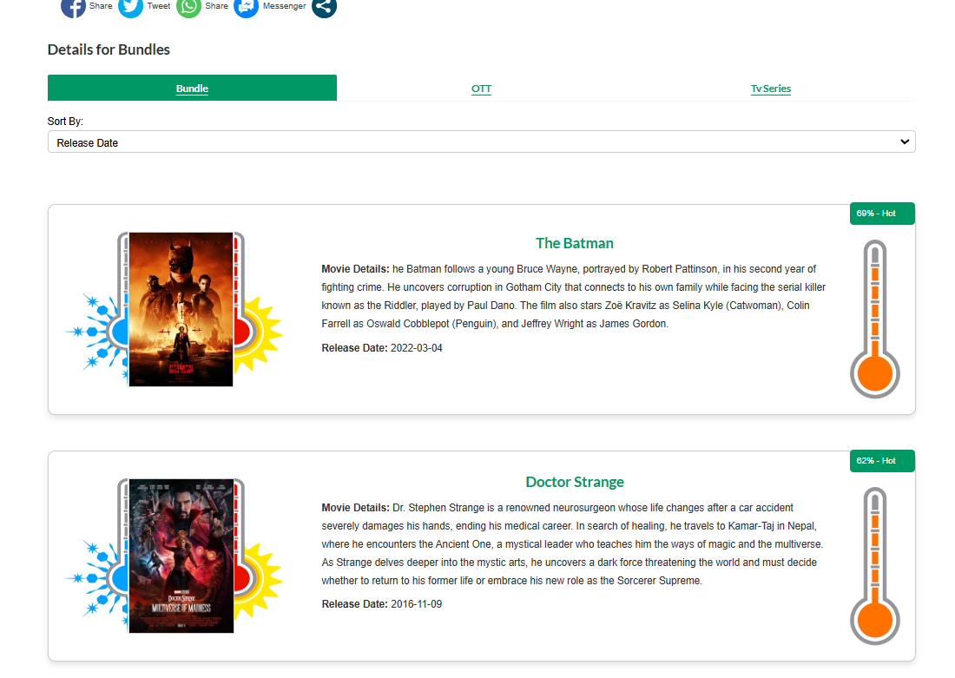
2) Scorcher page further enhancement requirement.
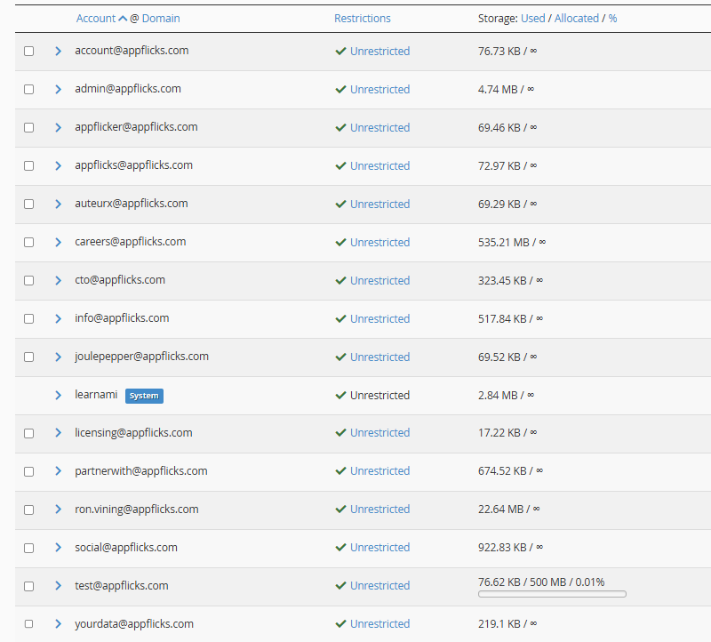
3) Passwords of these so that we can provide email on each user's actions.
4) Paypal setup for getting payments through appflicks store and donation page.
5) Any enhancement on View and Learn ?
6) Permission to delete Unwanted Plugins,pages and other things to removed that we have previously used but not using them now.
